Project Development Phase
Model Performance Test

Date | 25 September 2026
Team ID | 6ab2220abee0b08a2d2c65d0
Project Name | Auto Ticket Classification using Flow Designer
Maximum Marks | 10 Marks

Model Performance Testing:
Project team shall fill the following information in model performance testing template.
S.No. | Parameter | Screenshot / Values
1. | Data Rendered | Data source: u_incident_workflow table on ServiceNow. Fields rendered: Number, Caller, Category, Subcategory, State, Short Description, Assigned Group.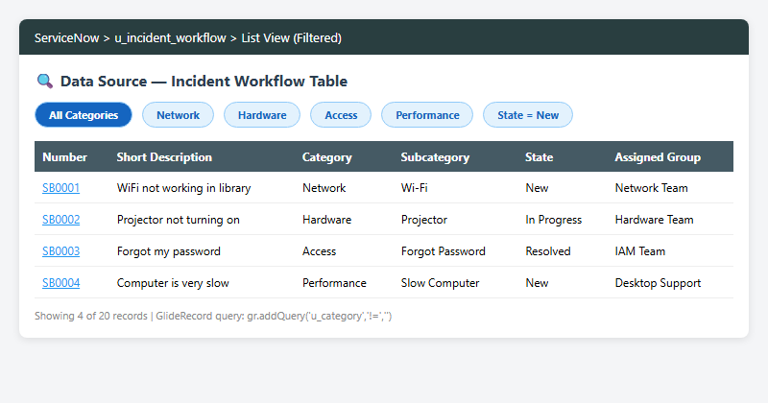
2. | Data Preprocessing | Auto-classification via Flow Designer (keyword parsing). No manual ETL needed. Data is clean at insert time due to Business Rule logic.
3. | Utilization of Data Filters | Filters applied: Category, State, Assigned Group, Date Range. Used ServiceNow list filters and report conditions.
4. | DAX Queries Used | N/A (ServiceNow uses GlideRecord queries instead of DAX). Example: gr.addQuery("u_category", "Network"); gr.query();
5. | Dashboard Design | No of Visualizations / Graphs: 3 (Pie Chart - Tickets by Category, Bar Chart - Tickets by State, List Report - All Incidents)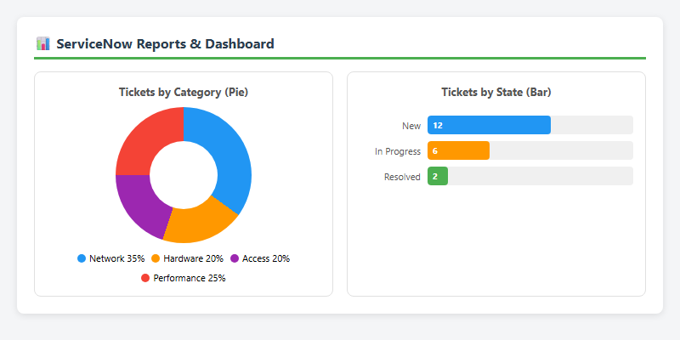
6. | Report Design | No of Visualizations / Graphs: 3 (built using ServiceNow Report Designer with grouping by Category, State, and Assignment Group)

